EASY System

Self Service – Expense Claims
Contents
Aim 3
Objective 3
Pre-requisite 3
Background 3
Expenses Workflow 3
Making an Expenses Claim 4
Assignment Information 5
Making a Claim 6
Mileage Claims 6
Other Claims 9
Entering Claims 11
Editing a Claim 12
Unsubmitted Expense Claims 12
Submitted Expense Claims 13
Accepted Expense Claims 14
Rejected Expense Claims 15
Archived Expense Claims 15
Favourite Places 15

Aim
This chapter is designed to explain how you make a claim for the reimbursement of expenses. You will also be taken through the facilities available to help you the monitor the progress of expense claims that that you have submitted for payment.

Objective
After reading this chapter you will be able to:
- Make an Expenses Claim
- Monitor the status of your expenses claims
- Respond to rejected Expense Claims

Pre-requisite
It is assumed that to be able to make an expenses claim that you have viewed the “Easy Manual - Introduction to Easy”.

Background
The EASY system receives regular downloads of data from the NHS Electronic Staff Record (ESR), and it is this data that provides the background record that enables you to quickly complete a claim for the reimbursement of mileage and other expenses.

Expenses Workflow
The following diagram shows the processes involved when you of complete an expenses claim. While the processes involved are performed electronically, they follow the basic model of a paper based system where expense claims are authorised by your manager and actioned by the Payroll Department.

Making an Expenses Claim
The whole process of making and monitoring the progress of expense claims is accessed through Self Service Expenses screen. To display the Self Service Expenses page, you click on the Expenses link that appears under the Self Service heading in the Navigation menu.

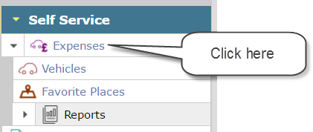

Your name and current assignment will normally appear in the list box at the top of the Self Service Expenses screen. When the list box does not show your name, this normally indicates that you have more than one assignment (job). You will need to click on the list box to select the job (assignment) in which you incurred the expenses that you wish to claim reimbursement for.

Once you have selected the appropriate assignment, the screen will show your assignment information (Job and Base) as well as the current progress with any expense claims for that assignment. You can expand and collapse the sections by clicking on the header to focus on the entries you wish to view.
We will cover each of these sections in more detail later in this chapter.
The View Archived Claims is explained later in this guide.

Assignment Information
This section is designed to provide you with details of the information held on the Electronic Staff Record System (ESR) in relation to your assignment (Job). If you have multiple assignments, then this information may change depending on the assignment you selected.
Important Note - This information is essential and is used to calculate any adjustments to mileage claimed so it is essential that you check the information is correct. Any errors should be notified to your manager for investigation. If you change your home address, you should not claim expenses until the change has been reflected in ESR otherwise any adjustment calculations may be incorrect.

Making a Claim
To make a claim for expenses, you will need to click on the Add/Edit button at the top right-hand side of the Unsubmitted Claims section to open the New Claims screen.
The New Claims screen has two sections covering Mileage Claims and Other Claims respectfully. The following looks at these sections in greater detail.

Mileage Claims
This section is designed to enable you to claim the appropriate mileage allowance whenever you use a vehicle on official business.
The Mileage Claims section has a blank row to enable you to start entering your claim for mileage reimbursement.

There are several fields and icons that are used in the process and these are explained in more detail below.

Date
This is the date that the journey occurred on. You can either enter the date in the field or select the date from the calendar that appears when you click on the date picker icon on the right-hand side of the field. While the date can be entered using different input formats, e.g. dd/mm/yy, dd-mm-yy or dd.mm.yy, it will be displayed in an easy to read format, e.g. 01 Jan 2010.

Expense Type
The list of expense types available varies according to your job and whether you are registered as a vehicle user. The correct selection of the expense type will enable correct payment.

Vehicle
For certain expense types you are required to specify the vehicle that you used for the journey. This is usually the case for the Business Miles expense type because the rate paid is based upon the vehicle’s engine size. Click on the Vehicle list box to select the vehicle that you used. If your vehicle is not there you need to have it registered.
The PTR Miles expense type is a unified rate, and normally you are not required to specify which vehicle was used. In which case, the Vehicle list box will be disabled (dark Grey).

Ward / Department
This allows you to select an alternative area where the cost of the expense should go. This will direct this part of the claim to the manager responsible for the chosen Ward / Department.

Alternative Base
This allows the user to select an alternative base. This is used when the user has two different bases.

Journey Reason
For certain expense types you may be required to provide a reason for the journey, e.g. Clinical Visit or Trust Meeting. This has no impact on your payment but is used for reporting and clarification purposes. Select the most appropriate journey reason.

Journey Start and End
The journey start and end fields are controlled by selecting from the list box on the left-hand side of the field. Here is what the items represent (note that not all these may be available to you):
- Base – when you select this icon your designated work base will appear in the adjoining field.
- Location – this indicates that you wish to select a location within the Trust, i.e. a hospital site or clinic. When you select location the magnifying glass icon will appear to indicate that you can search the locations available. By clicking on the magnifying glass icon a separate window appears with the list of Trust locations.
- Post Code – when you select this icon it indicates to the system that you wish to enter a UK post code, and the field to the right of the icon list box will become enabled to allow you to enter the post code.
- Home – selecting this icon will display your home post code in the field to the right of the icon list box.
- Odometer Reading – this indicates to the system that you wish to enter the odometer (mileometer) reading for the start and end of your journey.
- Favourite Places - You can select one of your saved favourite places. See near the end of the guide for more information on favourite places.
The EASY system is able to use the post code of the start/end location to obtain the distance involved.

Mileage
The Mileage column has two mileage fields, the top one is the Calculated Mileage field and the bottom one is the Claimed Mileage field. The following sections explain how they operate.

Calculated Mileage
The system checks the options selected in the Journey Start/End fields to determine how it should calculate the mileage for the journey.
Where the Odometer Reading is entered it is simply a case of deducting the start reading from the end reading.
For all other journeys, the system will use the start/end post code to determine the distance. The system will obtain mileage using one of the following methods:
- By checking the internal journey matrix. The Trust may have agreed distances between locations within the Trust or other local NHS organisations, and the matrix for these journeys can be stored within the system.
- By obtaining the distance from Here Maps. The system will pass the start and end post codes to Here Maps to obtain the distance based on the quickest route.
The calculated mileage is used as the baseline by the system when checking that the mileage claimed is within the Trust’s designated limits.

Claimed Mileage
The system will populate this field with the calculated mileage. However, this figure can be amended should the distance involved be higher or lower than the calculated mileage.
The figure entered in this field will be checked against the calculated mileage to ensure that the difference between the two is within the designated limits of the Trust.

No. of Pass
This is the number of other employees or members of an NHS organisation that were conveyed in the same vehicle while on NHS business. By entering the number of passengers in this field you are claiming the passenger allowance for that journey.

Heavy Equip.
If you are claiming for the carriage of heavy equipment under your terms and conditions for the journey, you need to tick this box.

Icons
At the end of a mileage claim row there are a number of icons that perform the following actions:
Add Row – by selecting this icon a blank row is added above the current row to enable you to enter the details of a new journey.
Additional Information – when you select this icon a text box appears to enable you to provide additional information in support of your claim, e.g. the additional mileage claimed may be the result of a road closure, or details of the passenger(s) being claimed for.
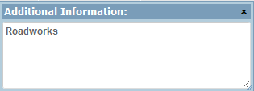
The icon is used to indicate that you have provided additional information in support of this claim.
Continue Journey – using this icon pre-fills a new row with most of the values from the current row so that it can be used as a continuation of the current journey, e.g. where you are returning to base or travelling on to another location.
View Map – selecting this icon will obtain the journey’s route using Here Maps.
Return Journey – selecting this icon completes a new row with the return journey details.
Clear this Row - This just clears the entries on this row.

Other Claims
The Other Claims section enables you to claim for the reimbursement of expenses and charges necessarily incurred whilst on official business.
The Other Claims section has a blank row to enable you to start entering your claim for these expenses.
The fields and icons that are used in this process are explained in more detail below.

Date Start/End
This is the date(s) on which the expense was incurred. In the case of an overnight stay, for example, you would enter the arrival and departure dates in the start and end date fields respectively.
You can either enter the date in the field or select the date from the calendar that appears when you click on the date picker icon on the right-hand side of the field. While the date can be entered using different input formats, e.g. dd/mm/yy, dd-mm-yy or dd.mm.yy, it will be displayed in an easy to read format, e.g. 01 Jan 2010.

Expense Type
The list of expense types available may vary according to your job or some other factor. For example, the Telephone Calls expense type may only appear if you provide on-call cover and you are entitled to claim the reimbursement of calls made on their own telephone while supporting a call.

Ward / Department
This functionality is currently not used by the Organisation.

Amount
This is the figure that you wish to claim for payment in respect of the expense incurred.

Receipt
If this field remains grey you do not require a receipt. Often a particular type of expense may only be reimbursed if you provide proof of the expenditure. Where that is the case, you will be required to indicate if you have Forwarded the receipt to your manager or Attached a file containing a copy of the receipt. When you specify that a receipt is to be attached to this claim a button will appear that enables you to choose the file involved.

Icons
At the end of other claim row there are a number of icons that perform the following actions:
Additional Information – when you select this icon a text box appears to enable you to provide additional information in support of your claim.
The icon is used to indicate that you have provided additional information in support of this claim.
Add Row – by selecting this icon a blank row is added above the current row to enable you to enter the details of a new journey.
Repeat Claim – using this icon pre-fills a new row with most of the values from the current row. By using the current row as a template for the next claim item it is hoped that the number of keystrokes will be kept to a minimum. For example, if you incurred car park charges on two separate occasions you could use the fill down but may only need to amend the date or amount.
Clear this Row - This just clears the entries on this row.

Entering Claims
As you start to enter claims you will become familiar with what each field and icon does.
You will notice that when you select items from lists the full description is not visible; this is due to the limited space available on the screen. However, when you hover over the field with the mouse pointer the full text of the field appears below the pointer.
You may even encounter some new icons, and one of these is shown on the sample screen above. The exclamation icon indicates that a warning condition has been triggered, which in this case means that the number of miles claimed (or amount claimed) is considered to be higher than would be expected even though it is still below the maximum allowable. This can be saved, but an explanation should be provided and once saved this will change to T.B.D (To Be Determined) in the payable column. See Below.
There may be occasions when an error icon appears. This indicates that the value claimed exceeds the maximum allowed by the Organisation. Whenever this type of icon appears you must correct the amount claimed before the system will allow you to save the screen. If you hover over the icon it will indicate the maximum allowable. Note that you cannot save this screen until you correct this amount.
When you are finished entering all the claim items, you can use the Save button at the top right-hand side of the screen to save what you have done and add more items later.

Editing a Claim
Once you have saved a claim (not submitted) it remains available for editing.
You can select the item you wish to edit by clicking in the box at the left of the item then clicking the Add/Edit Button.
When you are finished entering all the claim items, you can use the Save button at the top right-hand side of the screen to save what you have done and add more items later. Alternatively, you can submit your claim to your manager for authorisation by clicking on the Submit button that is at the top right-hand side of the screen.
The Reset button will remove any items that have been entered since the screen was last saved.
For now we will assume that you have saved the screen, and that you are back on the Self Service Expenses screen.

Unsubmitted Expense Claims
Once you have saved the items that you entered on the Claims screen you will be returned to the Self Service Expenses screen. You will see that the claim items that you saved now appear in the Unsubmitted Claims section.
Depending on your terms and Conditions of service, some claims may need adjustments made to them. In this case you will see T.B.D. in the Payable column. Once submitted you will be able to view the adjustment reason. (See below under submitted claims).
At the top right-hand side of the Unsubmitted Claims there are three buttons. The Add/Edit button takes you the Claims screen where you add new claims or change any of the items that you have entered previously.
The Withdraw and Submit buttons are used in conjunction with tick boxes on the left of the claim item row. If you select the Withdraw button, you are in effect removing the claim items marked with a tick from the claims process altogether. To verify that you are certain that you wish to withdraw the claim items marked, the following message will be displayed.
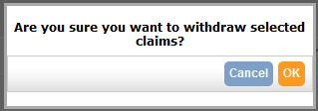
The process of submitting your expense claims here follows the same process if you had selected the Submit button on the Claims screen. As part of the submission process you are required to verify your claim by completing the Expenses Declaration which will look similar to the one shown below.
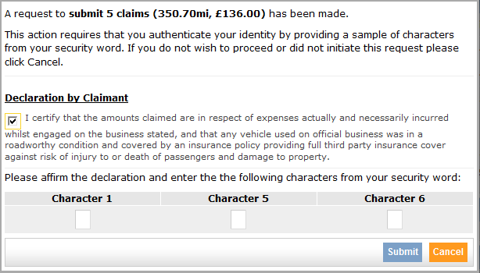
You will need to put a tick in the box that is part of the Declaration by Claimant, and enter the required characters from your security word. When you select the Submit button, an email will be sent to your manager and the submitted claims will now appear in the Submitted Claims section on the Self Service Expenses screen.

Submitted Expense Claims
Often there is a time lag between you submitting your expense claims and your manager processing these claims. During that period, you have the opportunity of amending claim items or withdrawing them from the claims process.
To amend claim items, you must put a tick in the box at the left of the claim item row and select the Unsubmit button. This will move the claim item(s) back into the Unsubmitted Claims section using the Add/Edit button to take you to the Claims screen.
You can view the actual amount that is payable net of any adjustments and also the reason for the adjustment by clicking on the adjustment tab.

Accepted Expense Claims
Depending upon the way in which your organisation operates, certain expense types may require final approval by the Payroll/Finance Department after your manager has authorised your expense claim(s). If an expense item does not need to be approved by the Finance Department, it will be deemed to be accepted. Once expense claim(s) have been accepted they are moved from the Submitted Claims Section to the Accepted Claims section, which ensures that you are aware of their current status.
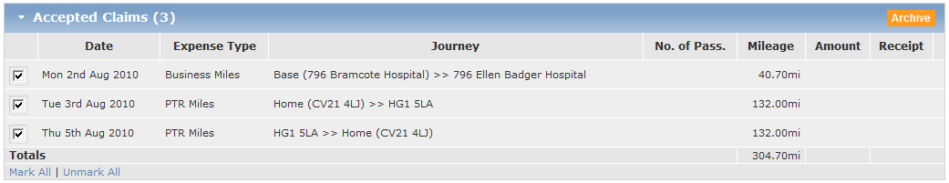
The accepted claims can be stored in your own expense claim archive by selecting the Archive button on the top right-hand side of the Accepted Claims section. If you need to refer back to an expense claim, you can do so by selecting the View Archived Claims button at the top right-hand side of the screen.
Once an expense claim has been accepted it goes into a queue waiting to be extracted in the next payment run.

Rejected Expense Claims
If for some reason your manager or the Finance Department have rejected an expense claim, you will receive an email and the rejected claims will appear in the Rejected Claims section.
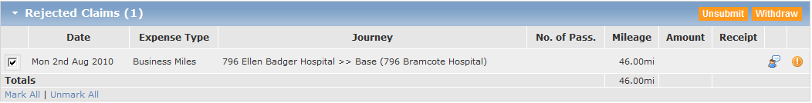

To view the reason why the claim was rejected you will need to click on the exclamation icon on the right of the claim item row. You can then elect to unsubmit the claim item, which will give you the opportunity of making a change or adding a comment to the claim before resubmitting the claim (Edit). Alternatively, you can withdraw the claim items that are marked with a tick by selecting the Withdraw button. This deletes the item.

Archived Expense Claims
As mentioned earlier, you can archive expense claims that have been accepted. To view the Claims History screen, you would select the View Archived Claims button at the top right-hand side of the Self Service Expense screen.
The expense claims are grouped according to the month and year to which they relate. You can expand and collapse those groups by clicking on the group header.

Favourite Places
There are often a number of places that you visit regularly such as to attend meetings, and you may find it easier to store these under a more familiar name, which is where the favourite places are useful. By selecting this option from the main Self Service menu you can set up a favourite location using either an organisations location (site) or by postcode.
Once you have entered a place, click ADD to save it to your lists.
When making entries to Mileage you will be able to select these by choosing the Start or End point by Favourite Places rather than the other options.

