EASY System

Introduction to EASY

Contents

Aim 1

Objective 1

Assumptions 1

Accessing EASY 1

Accessing the System in your Workplace 1

Accessing the System from Home 1

Logging into EASY 2

Issued by your EASY System Administrator 2

Self-Registration 2

Issued by System Administrator 3

Self-Registration 4

Logging in from outside your Workplace 6

System Messages 7

EASY Home Page 7

Shortcuts 7

Common Links 8

Menus 8

Hiding the Menus 9

Message Board 10

# Aim

This chapter is designed to introduce you as a new user to the EASY system, and how to use the features available to help you move around the EASY system.

# Objective

After reading this chapter you will be able to:

* Access the EASY system
* Log into EASY
* Change Password
* Create a Security Word
* Use the Shortcuts
* Use the Common Links
* Use the Menus

# Assumptions

It is assumed that you are familiar with the Microsoft Windows and Web Browser environments. The EASY system supports several Web Browsers, including Microsoft Edge, Google Chrome and Mozilla Firefox.

It is also assumed that your Organisation will have communicated to you that the EASY system is being implemented, where you will be able to access the system and the method you should use to log into EASY.

# Accessing EASY

The EASY System is an Internet based system and may be accessed from your workplace or home. In fact, you can access the system from any location that has an Internet connection.

## Accessing the System in your Workplace

Once the EASY system has been installed within your Organisation you may find a link to EASY on the Organisation’s Intranet, or your IT department may create a link to the EASY system within the list of programs or create a shortcut on your computer desktop. If EASY has been placed on your desktop you may see an icon similar to the one below.



To open EASY, you will need to click on the link on the Organisation Intranet or in your list of programs; or if you have the EASY icon on your desktop, you double-click on the icon. This should open the EASY Login page through your normal web browser.

## Accessing the System from Home

To access the EASY System from your home, or other location with an Internet connection, you will need to open a web browser.

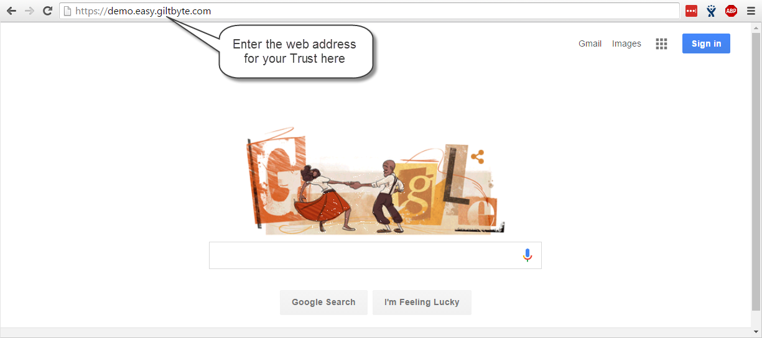

You will then need to enter the web address, sometimes referred to as the URL, that is appropriate for your Organisation and press the Enter key.

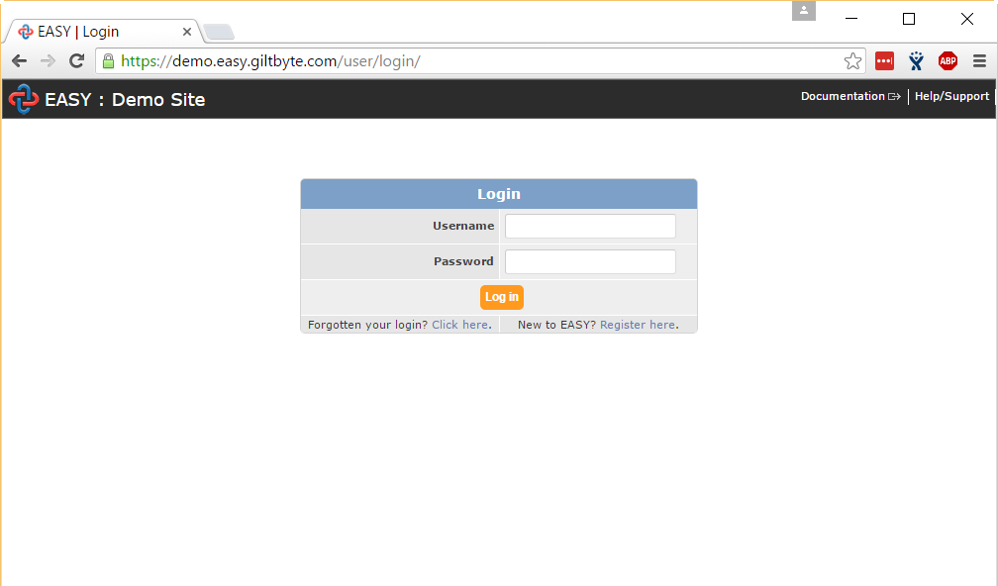

The EASY Login screen will be displayed to enable you log into the system or, if you are a first time user, to self-register with the system.

# Logging into EASY

The EASY Login page acts as the gatekeeper to the EASY system. By providing a valid Username and Password you are allowed into the system. But, as a first time user of EASY how do you obtain a Username and Password?

There are two methods of obtaining a User Name and Password, and these are described below.

### Issued by your EASY System Administrator

Your Organisation will have an EASY System Administrator who manages the EASY user accounts and the access to the different areas of the system. The EASY System Administrator may issue you with a Username and a temporary Password to enable you to log into EASY.

### Self-Registration

Your Organisation may allow you to register yourself as a user of EASY. This gives you access to the Self-Service area of the EASY system, e.g. to complete your timesheet or expenses claim. How this works is that you submit your work email address to EASY, and if this is recognised by the system you will receive an email that contains a token (computer jargon for a special code) or a link to a page in EASY.

## Issued by System Administrator

When you have been issued with your Username and temporary Password, type them in the relevant fields as shown in the example below.

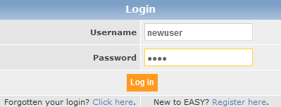

Please note that the username and password are case sensitive and you must use upper and lower case characters, as appropriate.

As this is the first time that you have logged into EASY, when you click on the **Log In** button or press the Enter key on your keyboard you will be taken to Password Change page.

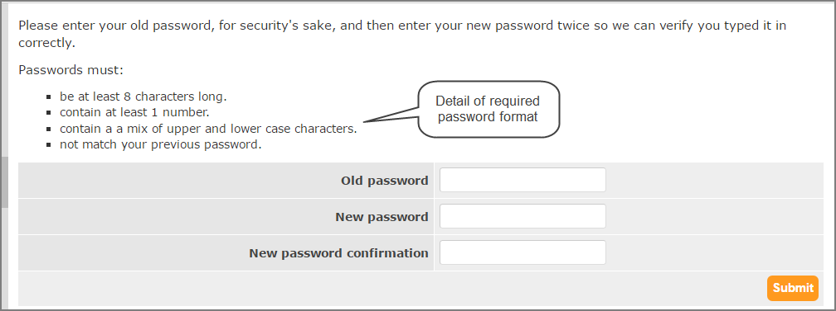

Enter your temporary password in the Old Password field, enter the password that you would prefer to use in future in the New Password field and re-enter your chosen password in the New Password Confirmation field. When you click on the **Submit**  button or press the Enter key, you will be presented with the Create Security Word page.

The EASY system asks you at different stages for 3 characters from your Security Word, this acts as your electronic signature. The security word must be between 6 and 20 characters in length, and must contain both letters and numbers, e.g. Hastings1066. It doesn't matter to the system if you use upper or lower case letters.

To complete the Create Security Word page (see below), you need to enter your chosen word in the Security Word and Retype Security Word fields. As a confirmation you need to enter your password (this is the new password that you entered earlier).

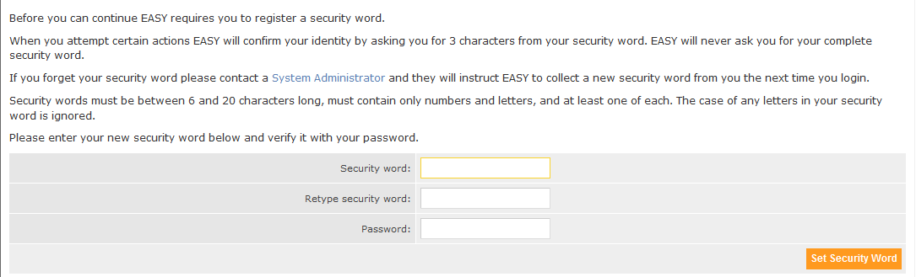

When you click on the **Set Security Word** button or press the Enter key, you will be presented with the EASY Home page.

## Self-Registration

To start the Self-Registration process, click on the Register here link at the bottom right of the EASY Login screen (see below).

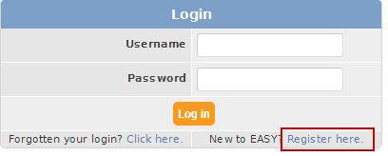

This takes you to the User Registration page where you enter your work’s email address (see example below).

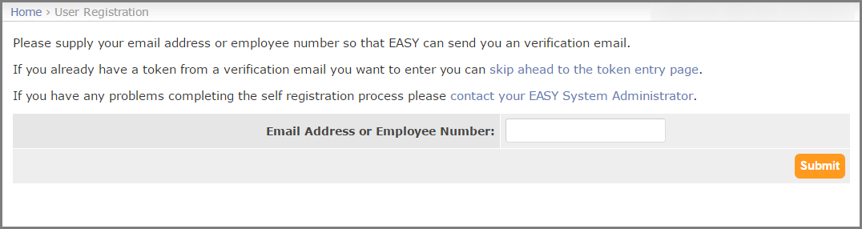

When you click on the Submit button or press the Enter key two things occur. Firstly, an email message similar to the one below will be sent to you.

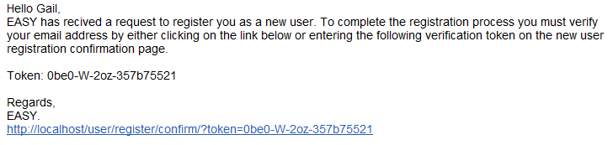

Secondly, the User Confirm Registration page (see below) is displayed.

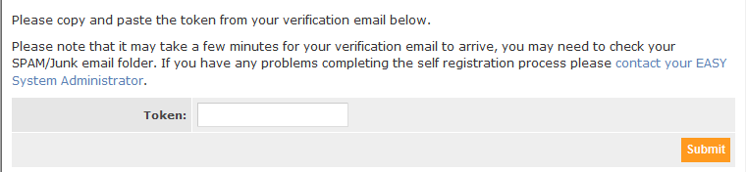

You will need to copy the Token from the email and paste it into the Token Field.

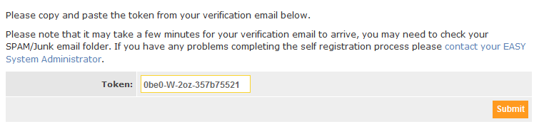

When you click on the Submit button or press the Enter key two things occur. The same two things occur if you clicked on the link at the bottom of email that was sent to you.

Firstly, an email, similar to the one below, is sent you with the User Name that EASY has created for you, and it is this User Name that you should use to log into EASY in future.

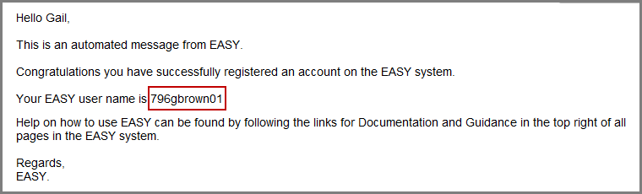

Secondly, the Create Password page (see below) is displayed.

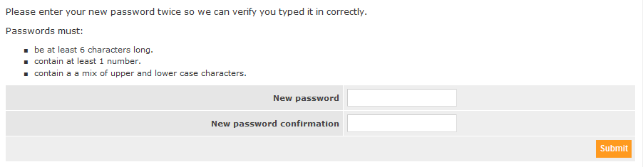

Enter the password that you that you wish to use when you log into EASY in future in the New Password field and re-enter that password in the New Password Confirmation field. When you click on the **Submit** button or press the Enter key, you will be presented with the Create Security Word page.

The EASY system asks you at different stages for 3 characters from your Security Word, this acts as your electronic signature. The security word must be between 6 and 20 characters in length, and must contain both letters and numbers, e.g. Hastings1066. It doesn't matter to the system if you use upper or lower case letters.

To complete the Create Security Word page (see below), you need to enter your chosen word in the Security Word and Retype Security Word fields. As a confirmation you need to enter your password (this is the new password that you entered earlier).



When you click on the **Set Security Word** button or press the Enter key, you will be presented with the EASY Home page.

## Logging in from outside your Workplace

As an additional security measure when you access the EASY System from a location that is not your workplace, you will be asked to confirm that it is you that is accessing the system from that location by entering three characters from your security word. For more information on this topic, please read the [Authorise IP Address](https://docs.easy.giltbyte.com/AuthoriseIPAddress/) article.

## System Messages

You may have noticed that when you successfully logged into EASY one or more messages (see example below) appeared to confirm that you password has been changed or your security word has been set. The messages displayed by EASY will normally disappear after a short period of time, or you can click on the cross at the right-hand side of the message to make it disappear sooner.



There are different types of messages displayed by EASY; giving you information, confirmation (as above), a warning or indicating an error. The length of time that the message is displayed for can be altered in the My Preferences page which is explained later in this manual.

# EASY Home Page

The EASY Home page (example below) is displayed when you have successfully logged into the EASY system. This page has a number of features that will help you manoeuvre around the system, change your preferences, and obtain help and guidance on the EASY system. These features are pointed out below, and they will be covered in more details shortly.

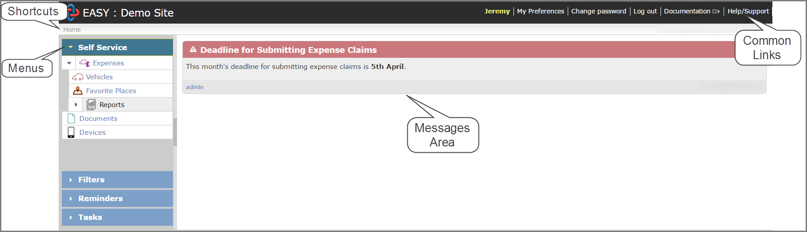

## Shortcuts

The Shortcuts, sometimes called the Breadcrumbs, are located at the top-left of the screen, and they lay a trail as you move to different layers of the system. This makes it quick and easy for you to move back to a previous level. In the example below, you would click on the Home link to return to the EASY Home page.

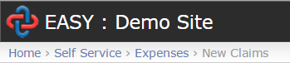

## Common Links

These are located at the top-right of the screen with either the Username or the user’s first name appears at the left of the useful links (see below).



The Common Links provide access to the following functions:

##### ***My Preferences***

You can define your own setting for certain features on the My Preferences page, e.g. how long messages are displayed.

Change Password

This will open the Password Change page allowing you to change your password at any time.

#### Log Out

By clicking on this link you will be logged out of EASY. Please note that this does not close the EASY web browser.

#### Guidance

This link only appears where your Organisation’s own guidance has been added to the particular page you are on at the time you clicked the link.

#### Documentation

This will display the EASY Online Documentation for the page you are on at the time you clicked the link. For example, if you were on the EASY Home page when you clicked the Documentation link the help screen for the EASY Home Page would be displayed.

#### Help/Support

You should click on this link to find out who you should contact if you need some assistance.

## Menus

The Menu bar is located to the left of the screen and may contain additional menus depending upon the page that you are on.

For most staff the Self Service and Reminders menus will be shown.

#### Self Service

The Self Service menu lists the activities that you have permission to access within EASY. For example, the following image shows the user is allowed to access the Self Service: Expenses, Vehicles and Favourite Places screens:

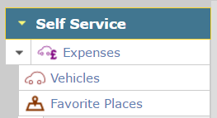

On occasions, the Self Service Menu may be collapsed as shown below, and your list of activities is not visible.



To expand the menu to see your activities, simply click on the heading that contains the word *Self Service*.

If you feel that you should have access to further parts of EASY, you should contact your EASY System Administrator who can modify your permission level.

#### Reminders

The Reminders are located below the Self Service menu, and provides a list of actions that require your attention. In the example below, the user does not have any reminders.

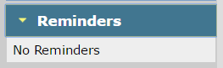

There may be times when it would be useful to hide the Menu because you have to use the scroll bar to see some fields on the page concerned; this is normally down to the screen resolution setting on your computer.

### Hiding the Menus

To hide the Menus, you click on the dark-grey bar that is in the centre of the border on the right of menu bar. As you hover over the central bar in the border it will change colour, usually to orange, and a hand with text underneath saying “Close” will appear.

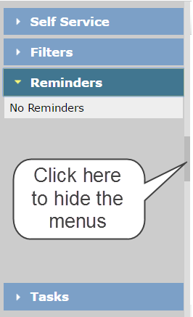

When the menu is hidden, a grey bar will be on the left-hand side of the page. When you hover over the border it will change colour, and when you hover over the dark-grey bar in the centre of the bar a hand with text underneath saying “Open” will appear.

If you hover over the border, but not on the central bar, you have some other features that you can use to resize or slide out the menu.

Resize

When the menus are not hidden and you hover over the border on the right, the resize arrows will appear and text saying “Resize”. You can make the menu bar wider or narrower by using the Windows drag and drop technique.

#### Slide Open

When the menus are hidden, and you hover over the border when the menu bar is hidden a hand with text say “Slide Open” will appear. This will slide the menu out to allow you to select an activity from the menu, which will hide automatically once you have made your selection.

## Message Board

This area of the EASY Home page is where your EASY System Administrator may post message that they feel is relevant to you as a user. These messages may be to tell you of forthcoming update to the EASY system during which time the system may not be available. A message could be classed as being important, in which case that message will have a red banner as opposed to less important messages that have a blue banner (see below).

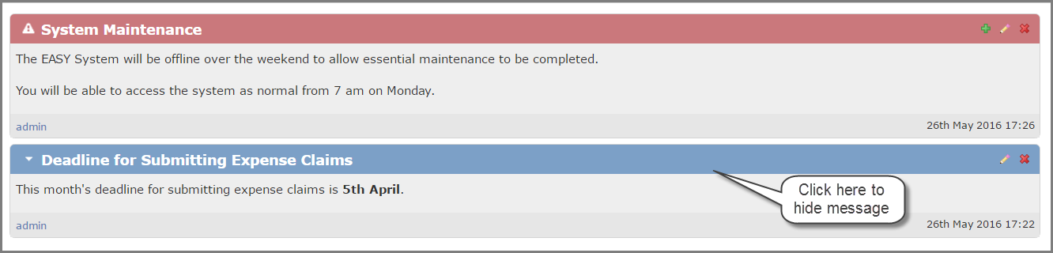

For the less important messages you can collapse the message so that the content is hidden. This is particularly useful if a few messages have been posted to the message board.