COMMS 1: Getting EASY to claim expenses

The NHSBSA Payroll Team is currently working on the implementation of a new e-expenses solution across the organisation, which will make claiming expenses easier.

The EASY Expenses System, which the team are currently building and configuring in partnership with the developers Giltbyte, will integrate with the Employee Staff Record (ESR) system.

More information on the change and what this means for you will be provided as things progress.

COMMS 2: Getting EASY to claim expenses

The NHSBSA will soon be introducing a new platform for you to claim expenses.

The new EASY Expenses System will enable you to access a web-based system and enter details of mileage and expenses which, once authorised, are automatically placed into the ESR system for payment. This brings the following benefits:

- EASY to use and accessible on a wide range of devices (Desktops, Laptops, Tablets or Smartphones) – this gives you maximum flexibility
- A mobile phone app that enables you to enter claim details and even take a photo of any receipts and upload them directly to your claim
- Where appropriate, the ability to enter the post codes of places visited with the system utilising “Google-Maps” to calculate mileage due
- You can set your own favourite places that you go to regularly to save time when making a claim
- Journeys can be extended and return trips added without fresh input – again, saving time when making a claim
- Self Service, allowing you to create your own user account and manage any password resets without having to call the NHSBSA helpdesk for support
The roll-out of the new EASY Expenses System will replace the current Integra 2 Expenses system.

What happens next?

The NHSBSA Payroll Team are currently working closely with the developers Giltbyte to build and configure the system. A new page will also be developed within the Finance section of the Hub which will offer guidance and access to supporting documents, quick user guides, FAQs and tutorial videos to make claiming and authorising expenses even EASY-er!!

If you have any questions, please email the Payroll Expenses Team who will also be keeping you up to date as things progress.
COMMS 3: Preparing for the introduction of Easy Expenses

Following the recent articles in the Loop, the NHSBSA is pleased to announce that the EASY Expenses system will go live in early 2019.

So, what does this mean?

When EASY Expenses becomes available, staff who currently have an Integra account will receive an email, along with instructions, inviting you to register your EASY User Account. You can then start making expense claims in EASY. All other staff who need to make expense claims post go-live can self-register for an account at any time.

As part of the EASY Expenses system, you will not be able to claim expenses undertaken 3 months (92 days) prior to the date of the claim. This is in line with the NHSBSA Travel Subsistence and Expenses Guidance. Therefore, we would encourage you to bring any outstanding claims up to date through the current Integra Expenses System.

The EASY system will change the way expenses are paid, moving from a weekly payment run to being paid monthly with your usual salary. It’s very user-friendly and easy to navigate and complete expense claims either online or via the mobile app.
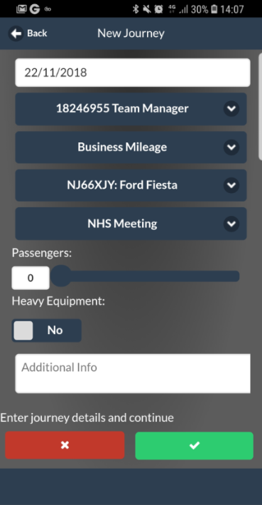
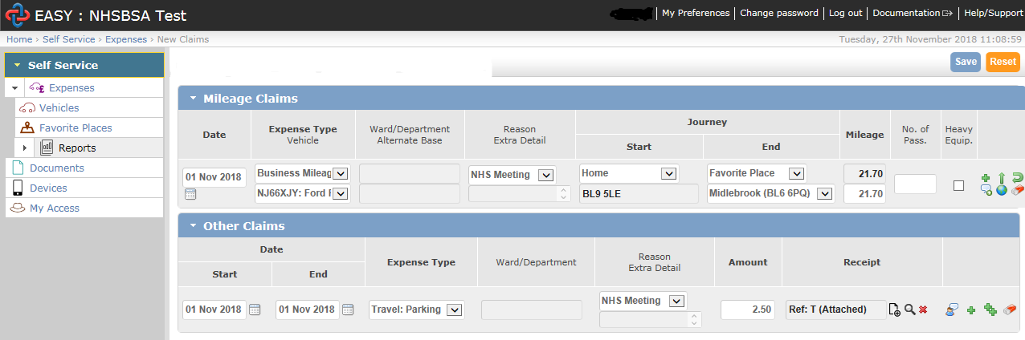
To further reduce any impact and unnecessary expense, all travel and accommodation must be booked through the NHSBSA appointed service agents as per the policy. This should be done as per the guides on the Hub.

Further information, including confirmation of go-live dates will be communicated over the coming weeks. In the meantime, if you have any enquiries about expenses, please email the Payroll Expenses Team nhsbsa.expenses@nhs.net.
COMMS 4: Launch of Easy Expenses

The NHSBSA is pleased to announce that the EASY Expenses system will go live on 21 January 2019.

EASY Expenses is being introduced in response to feedback and will replace the current Integra system, allowing you to claim mileage and expenses which, once authorised, are automatically placed into the ESR system for payment with your monthly salary. This brings the following benefits:

- EASY to use and accessible on a wide range of devices (Desktops, Laptops, Tablets or Smartphones) – this gives you maximum flexibility
- A mobile phone app that enables you to enter claim details and even take a photo of any receipts and upload them directly to your claim
- Where appropriate, the ability to enter the post codes of places visited with the system utilising “Google-Maps” to calculate mileage due
- You can set your own favourite places that you go to regularly to save time when making a claim
- Journeys can be extended and return trips added without fresh input – again, saving time when making a claim
- Self Service, allowing you to create your own user account and manage any password resets without having to call the Payroll Expenses Team for support.
Please note the existing rules and allowances will not be changing.

What happens when EASY goes live:

If you currently have an Integra Expenses account, you will receive an email on 21st January 2019, inviting you to register your EASY User Account; instructions will be supplied.

If you do not receive an invitation email and need to make an expenses claim, you can self-register for an EASY account at any time.

Guidance on registering your EASY Account and making / authorising claims is available on the Hub.
What do I need to do to prepare:

To ease the transition you should bring outstanding claims up to date and ensure they are authorised through the current Integra Expenses System by Friday 18th January 2019. The final pay date for expenses authorised in Integra is Wednesday 23rd January 2019.
Claims made after 18th January 2019 will need to be entered in the EASY Expenses system before the claim authorisation deadline each month and will be paid monthly with your salary. Please note that you will not be able to claim expenses undertaken 3 months (92 days) prior to the date of the claim.

Expenses Deadline Dates to March 2019

CLAIM AUTHORISATION DEADLINE | Pay Date
Friday 08/02/19 | Tuesday 26/02/19
Monday 11/03/19 | Wednesday 27/03/19

Your account in Integra will remain accessible as read-only for 6 months, allowing you to view historical claims, should you need to do so.

It is appreciated that some colleagues may have concerns about the change to the frequency of expense payments. If you do have concerns, please speak to your line manager who can contact the Payroll Expenses Team for further advice.

Any additional assistance can be provided by the Payroll Expenses Team on 0191 279 0858 or by emailing nhsbsa.expenses@nhs.net.

