Using the new EASY expenses system
The NHSBSA is pleased to announce that the EASY Expenses system will go live on 21st January 2019.
Those staff who currently have an account in the current Integra Expenses system will be issued with an email on 21st January 2019, inviting you to register your EASY User Account and instructions will be supplied.
For staff who do not initially receive an invitation email, should you wish to make claims, you can self-register for an EASY Expenses account to access the system. Details will be available on the Intranet on how to access the system via the following link: http://thehub.nhsbsa.nhs.uk/FinanceHome/Pages/Expenses.aspx
Don’t forget to submit any outstanding Expense Claims in December in the current Integra Expenses System as access will no longer be available after 18th January. Any outstanding claims less than 92 days old can be submitted in the EASY system.
Mileage Claims
For those staff claiming any mileage claims, you will first need to enter your car details and this will then be authorised by the Payroll Expenses Team. Please refer to the Introduction to EASY user guide available on the intranet via this link.
Items not eligible for Expense Claims
As stated in the “Finance Guidance: Travel, Subsistence and Expenses”, the following must be adhered to:
- all travel and accommodation must be booked through the NHSBSA appointed service agents as per the policy. This should be done as per the guides on the Hub.
- Where business travel mileage for one return journey is 90 miles or more, a hire car should be used and booked via the approved NHSBSA appointed service agents.
Amending Cost Centres
Expenses will be costed to the claimant’s cost centre held within ESR. Those staff who may be working on projects and need to charge their expenses to a different department or cost centre, may do so subject to authorisation from the relevant manager for the chosen cost centre.
Expenses Deadline Dates
Input and Authorisation Deadline dates will be available to users via the Notice Board within the EASY Expenses system and also on the Intranet.

Authorising Manager / Supervisor
EASY Expenses uses an interface with ESR to ensure it is updated with Users as staff join the organisation, move within it or leave. If, for any reason, your claim is not being submitted to the correct authorising manager / supervisor, then please contact the Payroll Expenses Team to resolve.
Help & Support
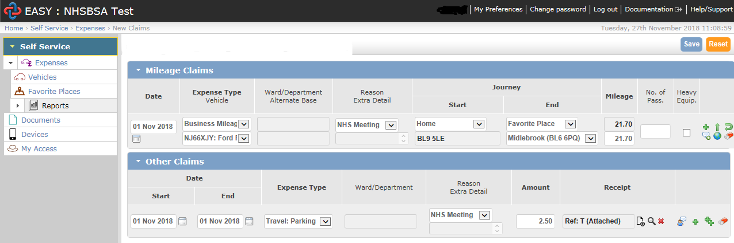
The EASY Expenses system is very user-friendly and easy to navigate and complete expense claims. If you need any assistance, you will find links within the system to User Guides and Help and Support.
The Expenses page on the Intranet also has User Guides and FAQs, including links to the Expenses Policy and support information. This can be accessed via the following link: http://thehub.nhsbsa.nhs.uk/FinanceHome/Pages/Expenses.aspx
Any additional assistance can be provided by the Payroll Expenses Team on 0191 279 0858 or by emailing nhsbsa.expenses@nhs.net.

