EASY Expenses System

  - FREQUENTLY ASKED QUESTIONS

Contents
1. What do I need to access the system? 3
2. How do I get to the system? 4
3. How do I get my Username? 5
4. How do I register with the EASY system? 5
5. What should I do if I have forgotten my password? 9
6. I’ve forgotten my security word 10
7. How do I contact the System Administrator? 10
8. I can’t access the system 11
9. My assignment is different from the one listed in EASY 11
10. My Base is different from the one listed in EASY 11
11. My home address is different from the one listed in EASY 12
12. My vehicle is different from the one listed in EASY 12
13. How can I add a favorite place? 12
14. How is my mileage calculated? 13
15. What if my mileage is less than the mileage calculated? 13
16. If I have travelled further than the calculated mileage, can I claim for that journey? 14
17. How can I let my manager know why I have claimed a higher mileage? 15
18. What should I do with my receipts? 15
19. When do I submit my claims? 15
18. How can I check on previous claims that I have made? 16
20. I’ve just got a new car; how can I add it to the system? 16
21. How do I put in my vehicle documents? 17

What do I need to access the system?
You will need:
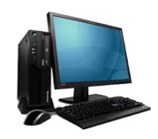

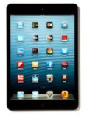

plus
a Web Browser

For example:
Google Chrome Internet Explorer version 8 or above Opera
Safari Mozilla Firefox

How do I get to the system?
There is a link to the system on the Trust’s Intranet Page

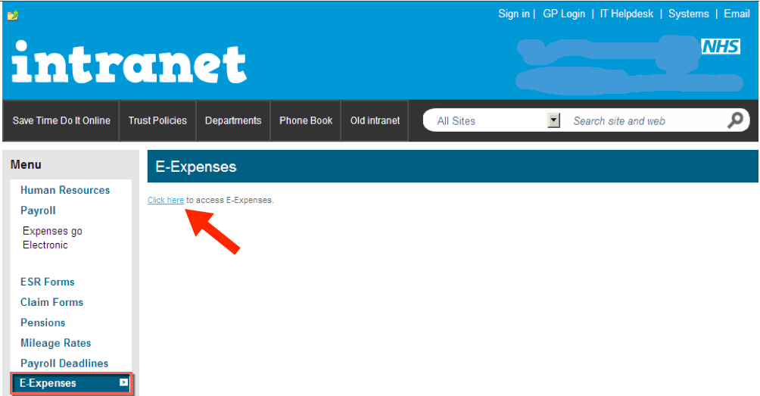

or, open a web browser and enter the web address

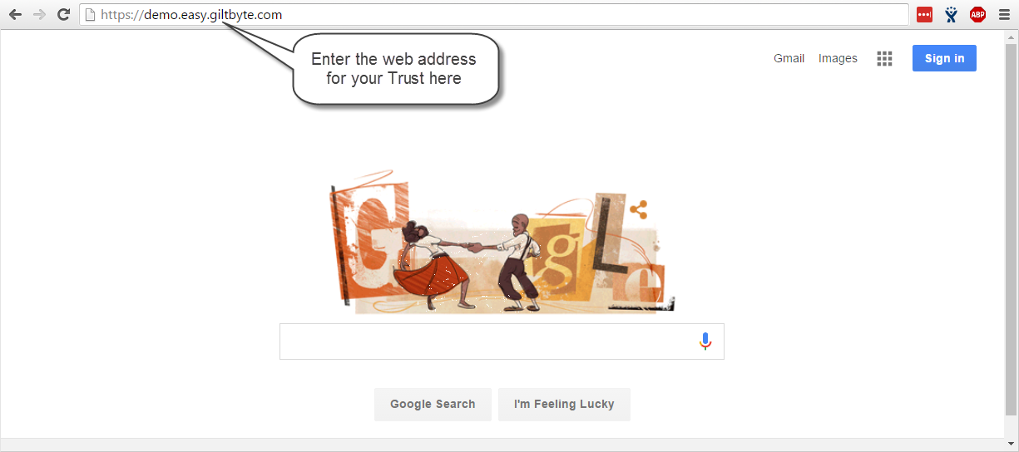

How do I get my Username?
For managers who authorise expense claims a username is often allocated by the local system administrator. If you are a manager and you haven’t been issued with a user name, you should contact your local system administrator.
If you are not a manager, you can self-register with the system.

How do I register with the EASY system?
If you’ve never made an expenses claim using the EASY System, you will need to register with the system to create a user account.

Click on the Register here link on the login page.
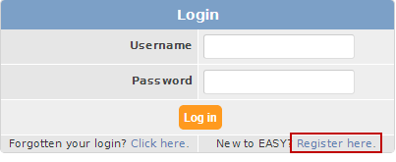

Then you will be asked to provide your Email Address or Employee Number.
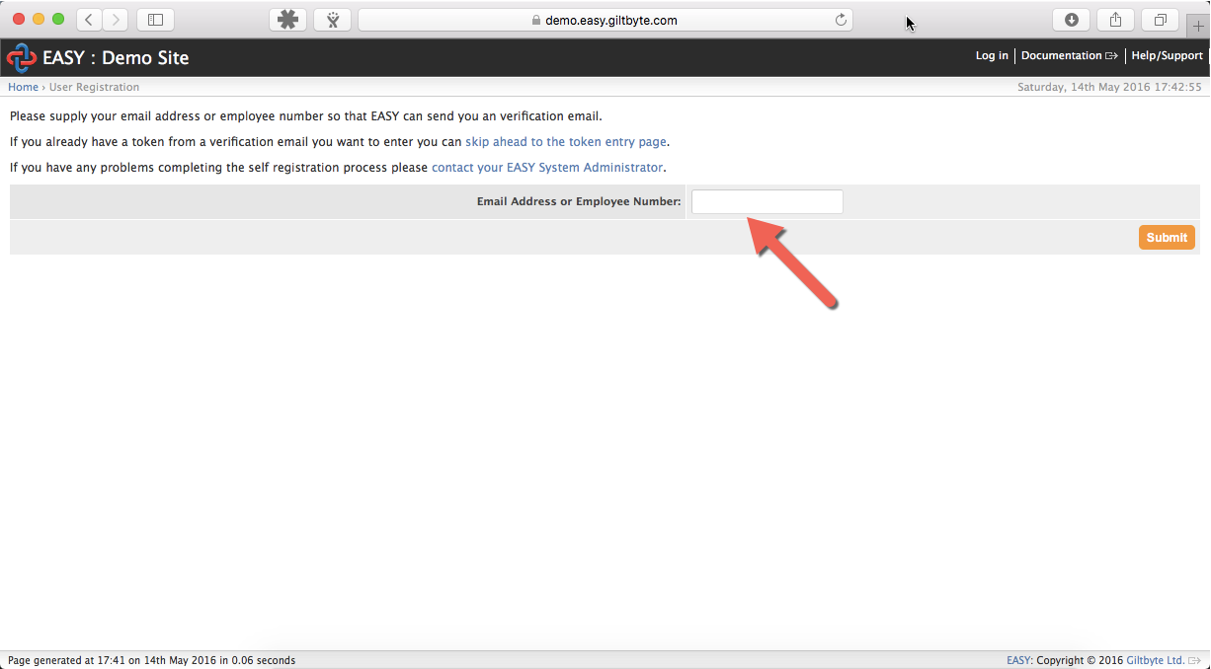

You will receive an email that has a token (this is just a temporary password). Please note that the token is only valid for 2 days.

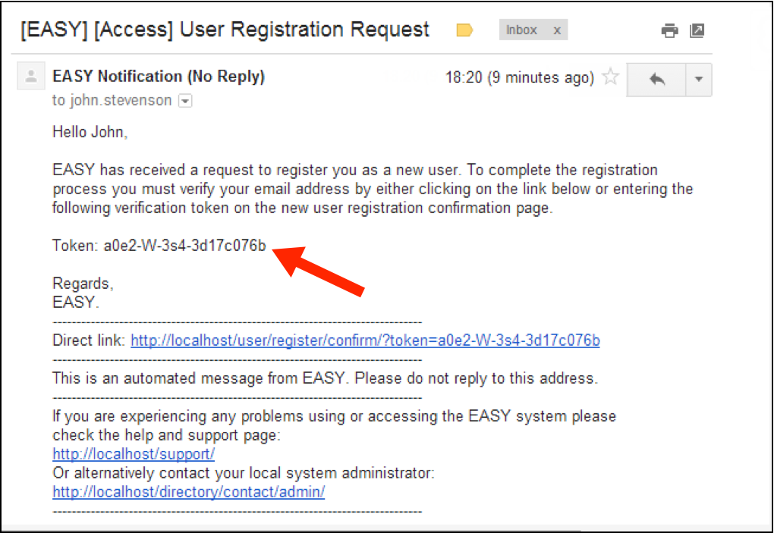

You have 2 options:
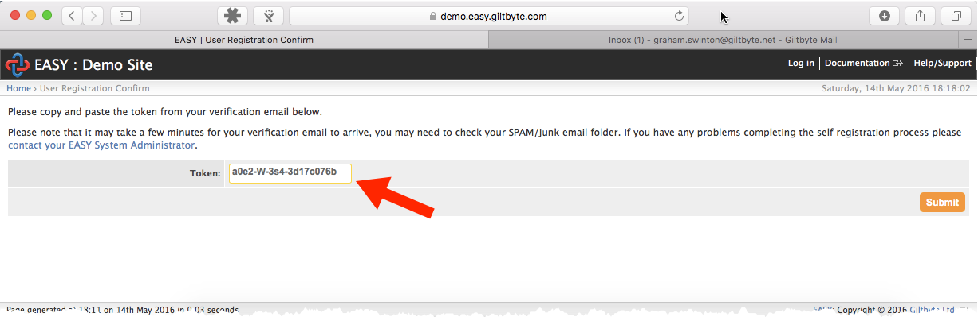
- Copy and paste the token into field on the Token Entry page and click on the Submit button.
- Or, you may find it easier clicking on the link in the email
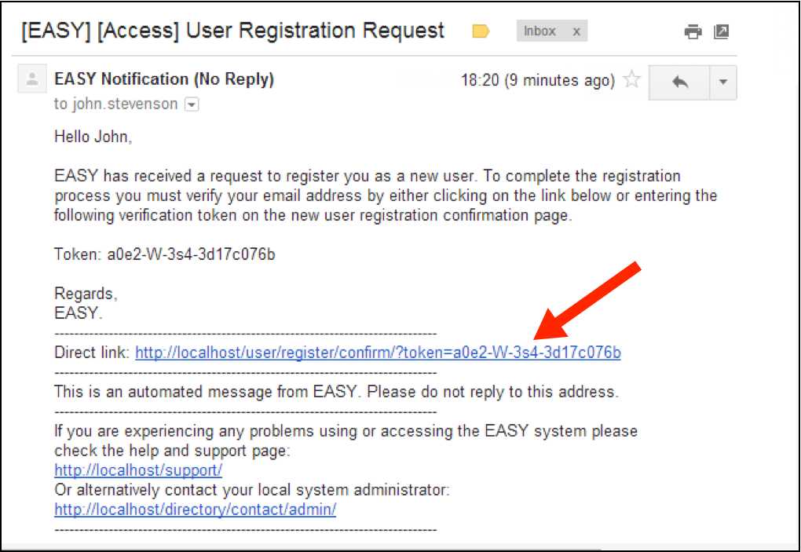

You’ll then be asked to create a password.
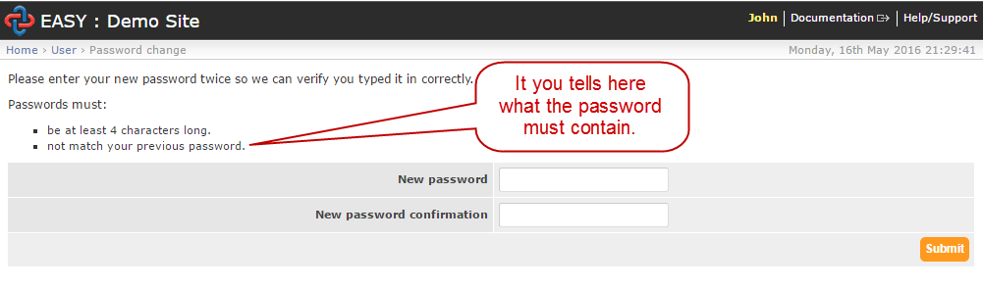

Next you’ll be asked to provide a security word.
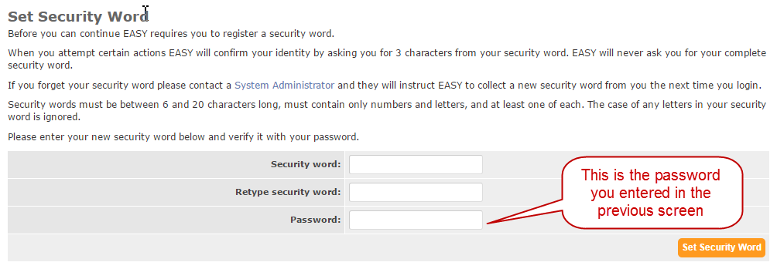

Lastly, you will receive an email confirming your username.
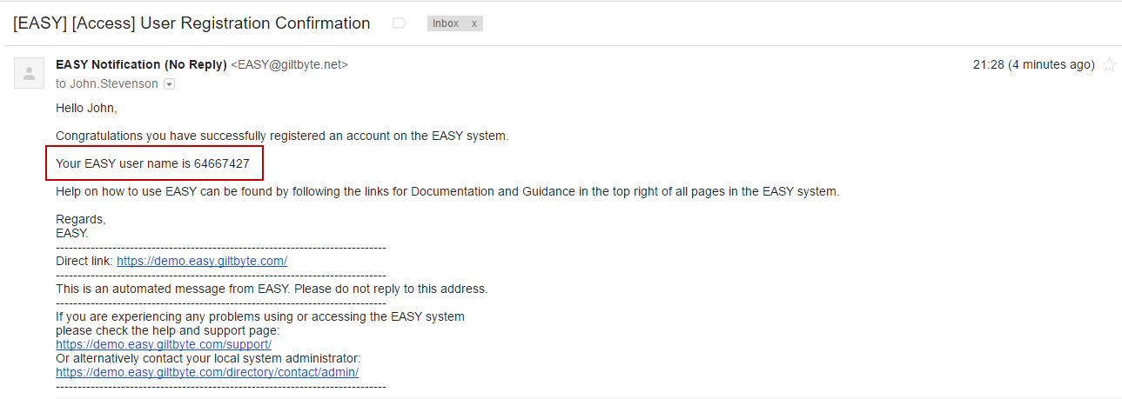

What should I do if I have forgotten my password?
Click on the Forgotten your login? link on the login screen.

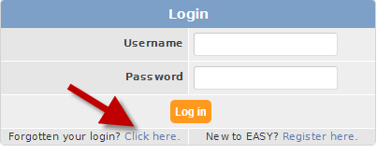

You’ll then be asked to provide your Employee Number, Username or E-mail address.

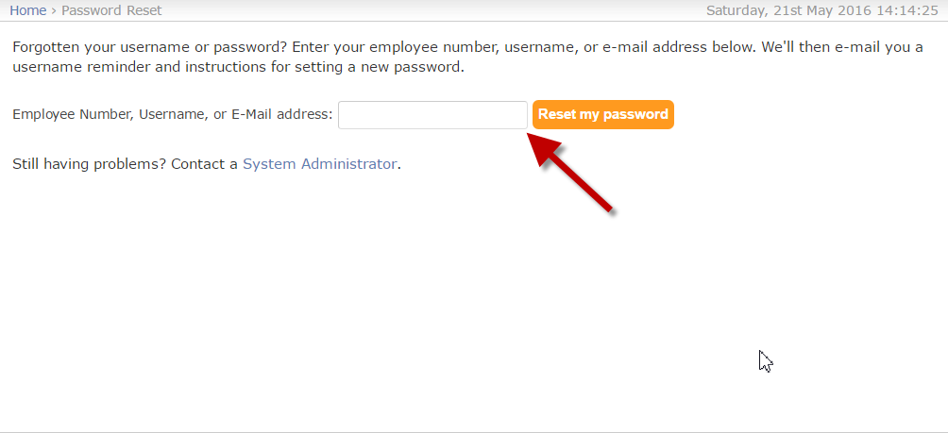
An email will have been sent to you with a link that will take you to the screen to create a new password.

I’ve forgotten my security word
You will need to contact your local System Administrator who can organise another one for you.

How do I contact the System Administrator?
If you look at the top right of the login page, you will see Help and Support. If you click on this, you will see the contact details for your System Administrator.

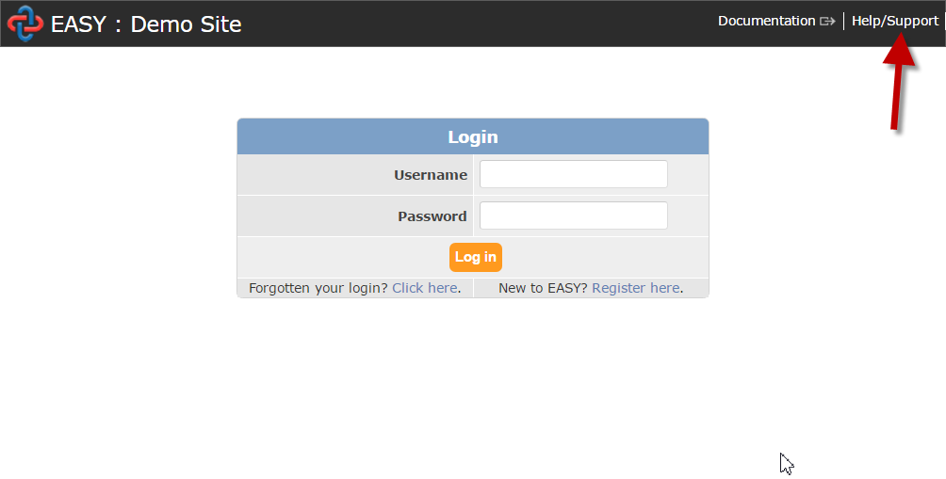

I can’t access the system
This happens if you have made over three attempts and put in an incorrect password. You will need to click on Forgotten your login link to reset your password.

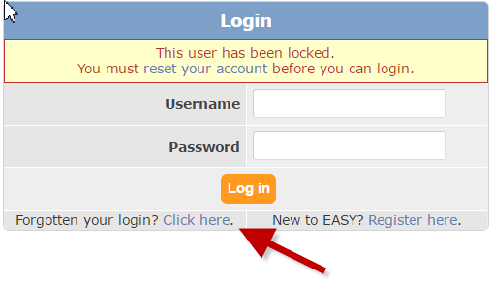

My assignment is different from the one listed in EASY
The Information in the EASY system is taken from the details held in ESR (Electronic Staff Record). You will need to contact your System Administrator who can update the system for you. See FAQ 5. How to contact the System Administrator.

My Base is different from the one listed in EASY
The information in the EASY system is taken from the details held in ESR (Electronic Staff Record). You will need to contact your System Administrator who can update the system for you. See FAQ above How to contact the System Administrator?

My home address is different from the one listed in EASY
The information in the EASY system is taken from the details held in ESR (Electronic Staff Record). You will need to contact your System Administrator who can update the system for you. See FAQ above How to contact the System Administrator?

My vehicle is different from the one listed in EASY
The information in the EASY system is taken from the details held in ESR (Electronic Staff Record). You will need to contact your System Administrator who can update the system for you. See FAQ above How to contact the System Administrator?

How can I add a favorite place?
Click on the Favourite Places link in the Self Service menu.
Complete the screen with your favourite place then click the Add button.

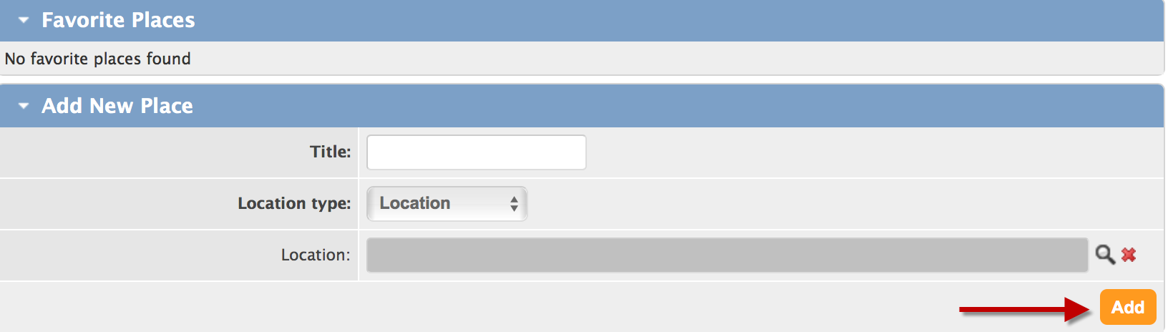

How is my mileage calculated?
Your mileage is calculated using Here Maps. If you click on the World icon in your mileage claim screen - it will display the route that has been used to calculate the mileage.

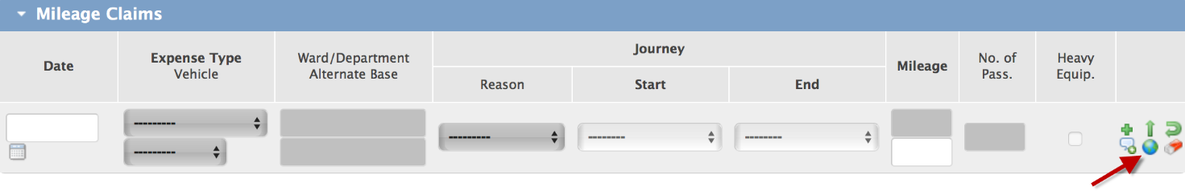

What if my mileage is less than the mileage calculated?
The top mileage value is what has been calculated. If you wish to claim a different amount - enter it in the box below.

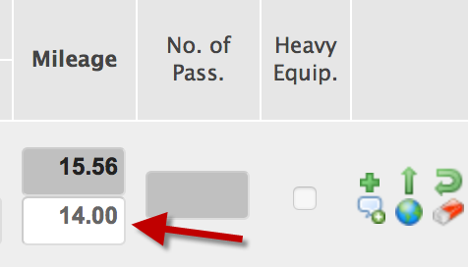

If I have travelled further than the calculated mileage, can I claim for that journey?
You can enter the mileage travelled in the lower mileage field. However, your Trust may have set a limit on what mileage you can claim, and your claim may be refused. If you hover your mouse pointer over the red symbol. It will tell you what the Trust will accept above the calculated mileage.

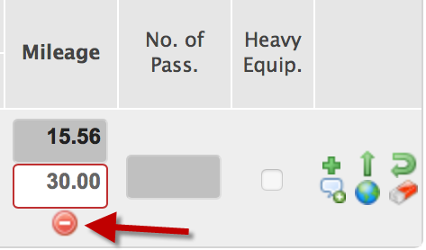

Your Trust may have set a mileage limit that it considers to be higher than expected, and this will be highlighted for your manager to investigate. above the calculated mileage that they will consider is acceptable.

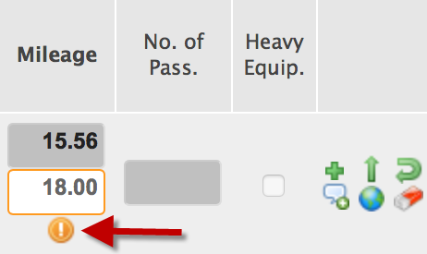

How can I let my manager know why I have claimed a higher mileage?
Click on the speech bubble icon,
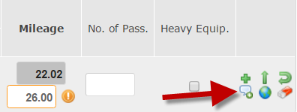

And add a note for your manager.
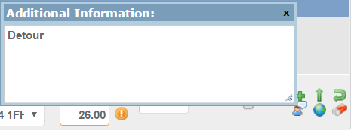

What should I do with my receipts?
You can attach the receipt to your claim by either scanning or photographing the receipt. Alternatively, you may forward your receipts to either your manager, or the payroll department, depending on your Trust’s policy.

When do I submit my claims?
Submit your claims at the same time that you would have submitted your claims previously. Usually this is done at the start of the month.

18. How can I check on previous claims that I have made?
Click on button when you are in Expenses Status screen (top right). Your latest claims will be displayed. If the dates you are interested in are not displayed, you can enter the dates you want and then click Refresh button.

I’ve just got a new car; how can I add it to the system?
Select the Vehicles link in the Self Service menu on the left. On the Vehicles screen, click on the Add button (top right).
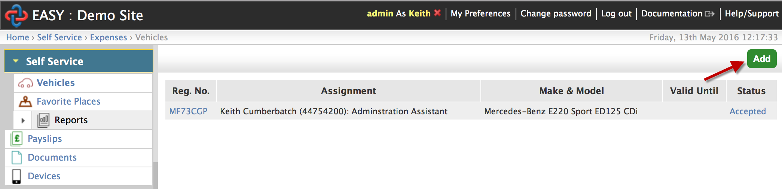

Complete the Vehicle details screen for your new vehicle, and then click Submit.

How do I put in my vehicle documents?
Select the Vehicles link in the Self Service menu on the left. Then click on the vehicle that you wish to add documents for.
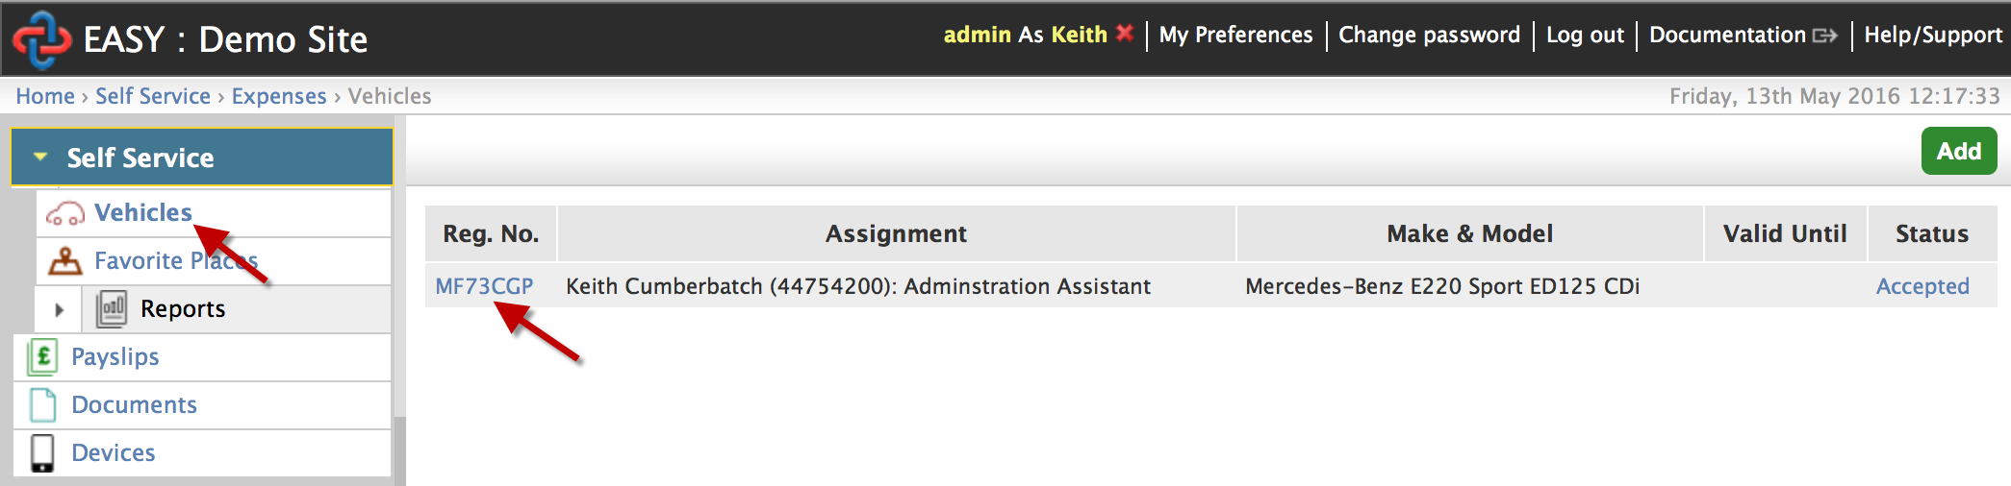
You then click on the drop down menu next to the document that you want to add. This will give you the option to either Forward or Attach the document. If you choose to attach the document, then scan or photograph it and choose the file and click Send. If you select Forward you will need to post your document to the relevant department / person
